MACHINE LEARNING

Subset of AI

Focuses on designing of systems

Allowing them to learn and make predictions based on some experiences which is data

AI

ML

Deep Learning

Ml algorithm is trained using training dataset to produce a model

new input data is introduces to ml algorithm and the prediction made is evaluated for accuracy

if accurate ml algorithm is deployed, else algorithm is strained again and again

types:  
supervised:

input- x …. Output- y  
forms an algorithm based on different inputs and their respective outputs…

so when any new inputs arrives the the system provides an output with the same algorithm

eg. Linear regression, random forest, support vector machines

eg.

When you say hey siri, call xyz… siri calls to that person using an algorithm which comes under supervised ml (Recurrent NN)

Online advertising (startdard NN)

Machine translation (language) (RNN)

Autonomous driving (hybrig neuro network)

Weather app

Biometric attendance

Predict credit worthiness of credit card holders in banks

Prediction of readmission rate of patient in healthcare sector

Analyse products the customers buy together in the retail sector

Structured data- each attribute has some corresponding data

Unstructured data- audio, image

Unsupervised

Input data X and no output

Creates clusters of data which are similar

The algorithm doesnot know regarding the cluster name

No correct answers

Algorithms: aprori algorithm, k-means algorithm, heirarcal clustering

Eg.

Bank- segment customers by behavioural charecteristics

Healthcare- categorise mri data by normal or abnormal

Retail- recommend products to customers based on their past purchases

Reinforcement

Interaction between environment and learning agent

Learning agent has two mechanisms exploration and exploitation

Exploration- trail and error bases output

Exploitation- acts based on knowledge gained by environment

On correct output- the machine is rewarded, which is then used to increase its exploitation knowledge

Correct- reward points, wrong- penalty

On wrong answer machine updates its policies

DEEP LEARNING

1. Deep neural network and deep learning

dl- Training neuro networks

neuro network- many neurons stacked together

large neuro network and more amount of data helps increase the performance of DL process

amount of labelled data (m)

small training sets- the region when the data is not much

scale drives deep learning progress- data, computation, algorithms

binary classification-

example… input x (an image) – output y (1 or 0) whether a cat or not

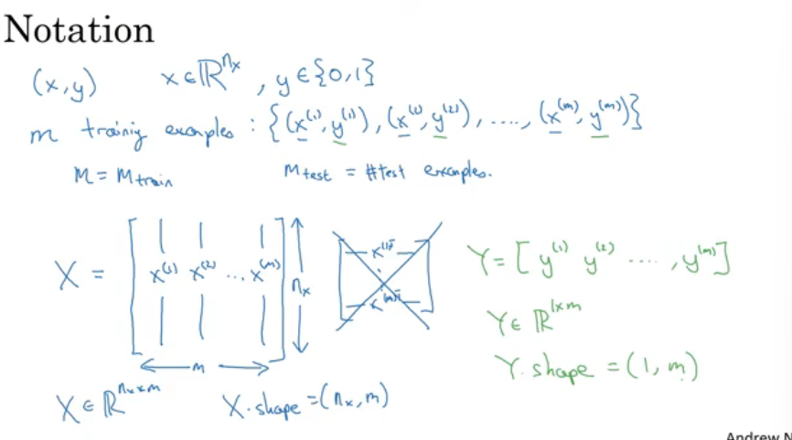

Logistic regression

Given x (an image)

Y^- prediction outcome

Cost function

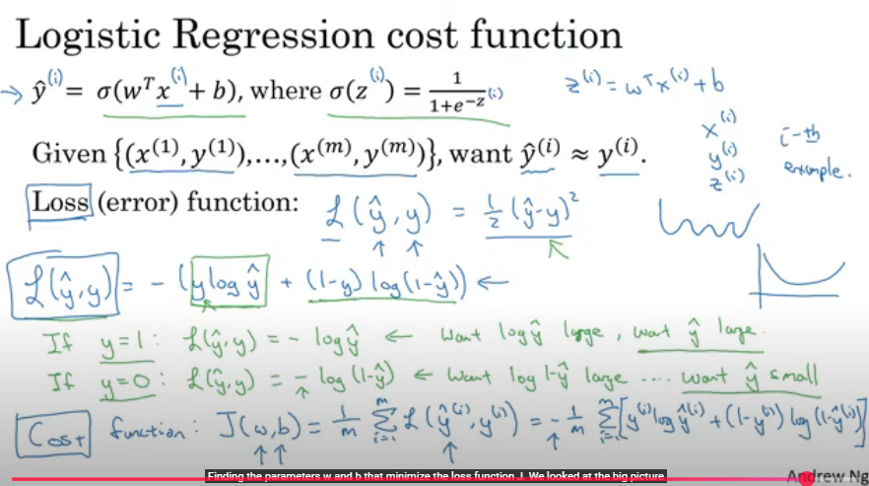

Gradient descent

Cost funtn is convex and we need to minimize cost function

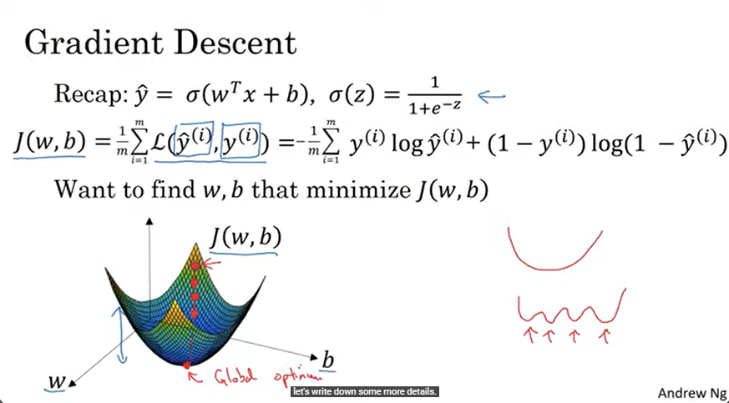

Changing values of w so that J is minimum

Alpha- learning rate

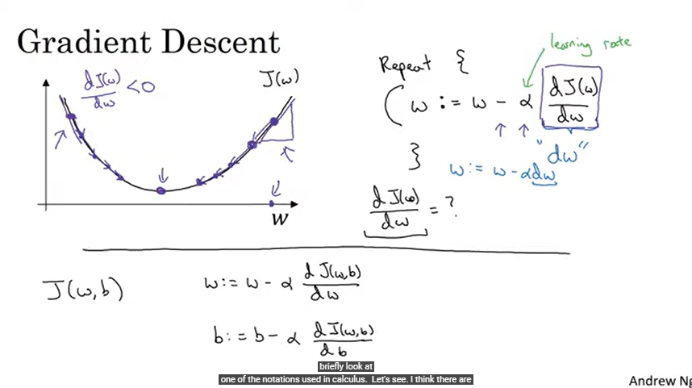

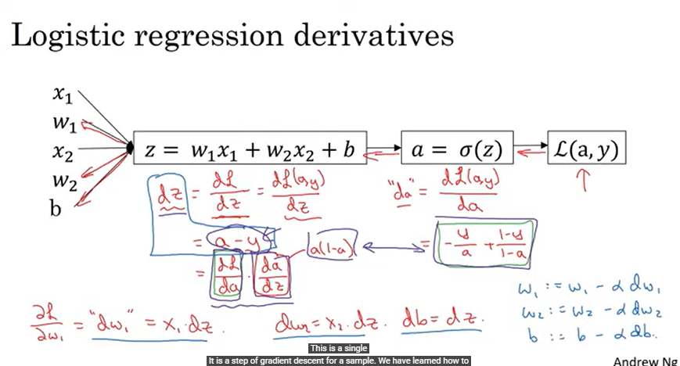

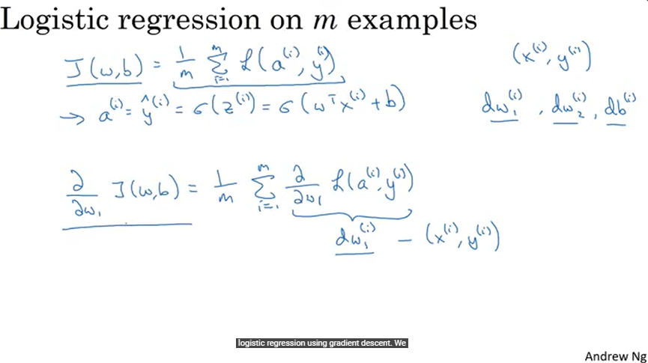

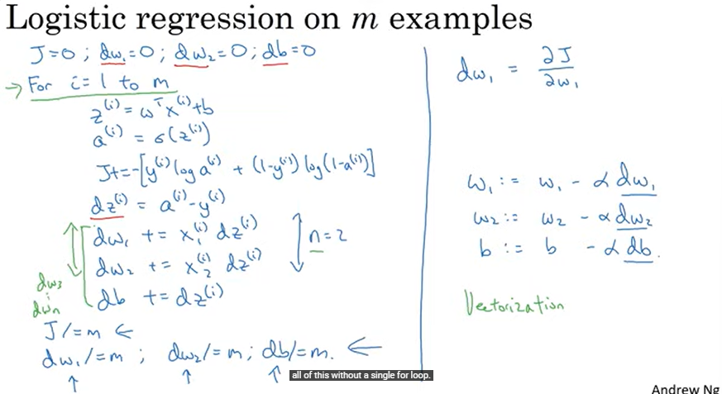

Vectorization

Vedctorisation helps reduce the for loops in the code

Vectorised version of a code takes less time…

